Kindergarten Digital Learning Activities
Reading activities:
Read 20 minutes per day. You can read books from home or on Tumblebooks and Bookflix.
To access: cobbk12.org
Parents
Digital Textbooks
Kindergarten- 2nd grade
Cobb Digital Library
Login: Firstname.lastname@students.cobbk12.org birthday 0106 (month/day)
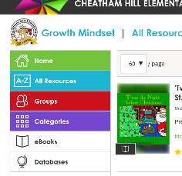
You will be in Mackinvia
Databases

Math activities:
- McGraw Hill student workbook
To access: cobbk12.org
Parents
Digital Textbooks
Kindergarten- 2nd grade
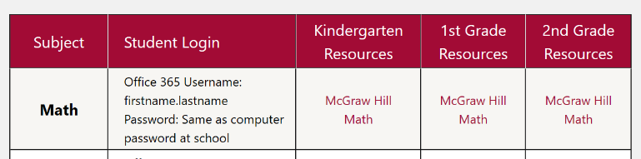
Math/ Kindergarten Resources/ McGraw Hill Math

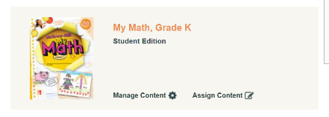
My Math, Grade K Student Edition

Chapter 5: addition, Chapter 6: subtraction, Chapter 7: compose and decompose numbers, Chapter 12: three dimensional shapes
- Brain Pop Jr.
To access: cobbk12.org
Parents
Digital Textbooks
Kindergarten- 2nd grade
Cobb Digital Library
Login: Firstname.lastname@students.cobbk12.org birthday 0106 (month/day)
You will be in Mackinvia
Databases

Brain Pop Jr.

Math: Number Sense, Addition and Subtraction, Measurement, Geometry, Data, Math Strategies
Writing Activities:
Research and animal or a person on Pebble Go. Write 5 sentences on the topic. Be sure to begin your sentence with a capital letter and end it with punctuation.
Challenge: Can you begin your writing with a hook and end with a conclusion?
To access: cobbk12.org
Parents
Digital Textbooks
Kindergarten- 2nd grade
Cobb Digital Library
Login: Firstname.lastname@students.cobbk12.org birthday 0106 (month/day)
You will be in Mackinvia
Databases
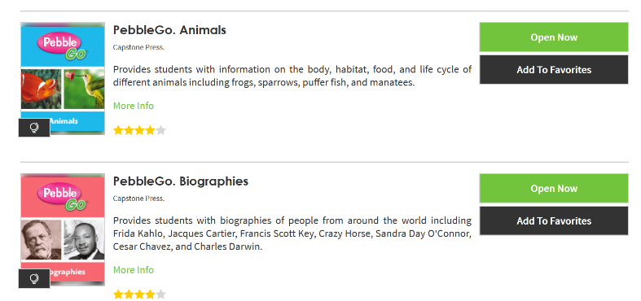

Science and Social Studies Activities:
- Practice your address. (home address, city, state, country)
- Social Studies Weekly Activities
To access: cobbk12.org
Parents
Digital Textbooks
Kindergarten- 2nd grade
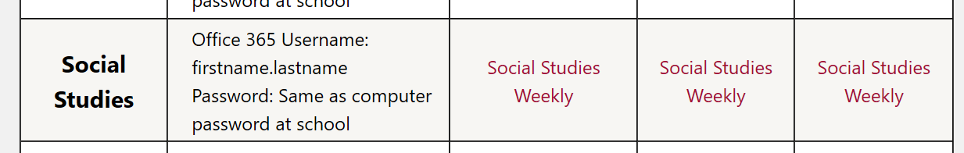
Social Studies/ Kindergarten Resources/ Social Studies Weekly

Social Studies Weekly: American Foundations
Week 10, 11, 22, 23, 24
- Brain Pop Jr.
To access: cobbk12.org
Parents
Digital Textbooks
Kindergarten- 2nd grade
Cobb Digital Library
Login: Firstname.lastname@students.cobbk12.org birthday 0106 (month/day)
You will be in Mackinvia
Databases

Brain Pop Jr.

Science: Pushes and Pulls, Parts of a Plant, Plant Life Cycle, Soil,
Rocks and Minerals.
Additional Resources:
Starfall.com
Abcya.com
Jackhartman on youtube.com
Scratchgarden on youtube.com
Preschool prep on youtube.com
Teachyourmonstertoread.com

